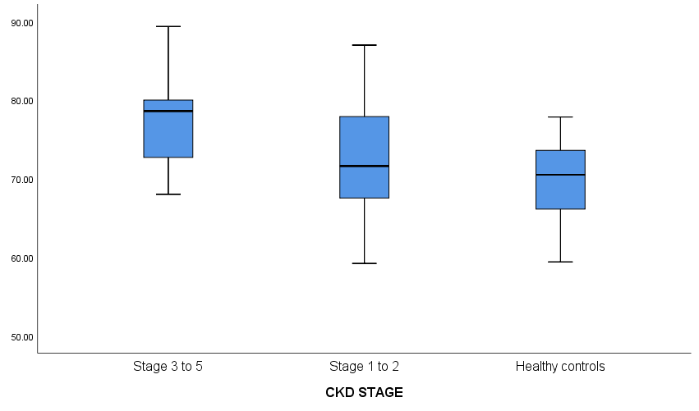

Enterrobacteriaceae DNA / ng/µL

70.5 [72.1-73.6]

71.6 [65.7-77.9]]

78.6 [72.7-80.0]

|  |  |  |  |
| --- | --- | --- | --- |
| **Variable** | **Median[IQR]** | | **p value** |
|  | CKD 3 - 5 | CKD 1 - 2 |  |
| ENTERO | 78.6[72.7-80.0] | 71.6[65.7-77.9] | **0.048\*** |
| LACTO | 0.58[0.00-0.62] | 0.64[0.60-0.79] | **0.047\*** |
| BIFIDO | 0.72[0.63-0.92] | 0.69[0.64-0.79] | 0.714 |

|  |  |  |  |
| --- | --- | --- | --- |
| **Variable** | **Median[IQR]** | | **p value** |
|  | CKD 3 - 5 | HC |  |
| ENTERO | 78.6[72.7-80.0] | 70.5[72.1-73.6] | **0.045\*** |
| LACTO | 0.58[0.00-0.62] | 0.71[0.32-0.81] | **0.043\*** |
| BIFIDO | 0.72[0.63-0.92] | 0.75[0.71-0.89] | 0.751 |

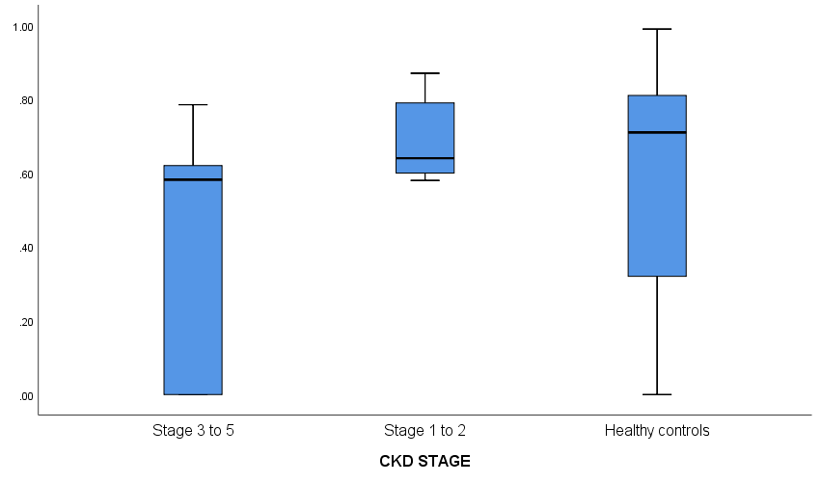

0.64 [0.60-0.79]

0.71 [0.32-0.81]

0.58 [0.00-0.62]

*Lactobacillus* DNA / ng/µL

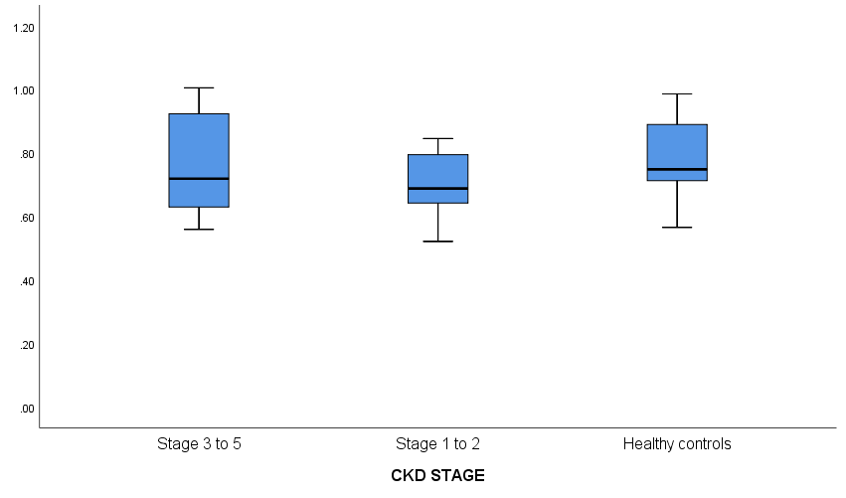

0.72 [0.63-0.92]

0.69 [0.64-0.79]

0.75 [0.71-0.89]

*Bifidobacterium* DNA / ng/µL